**CHAPTER 6**

**RESULT**

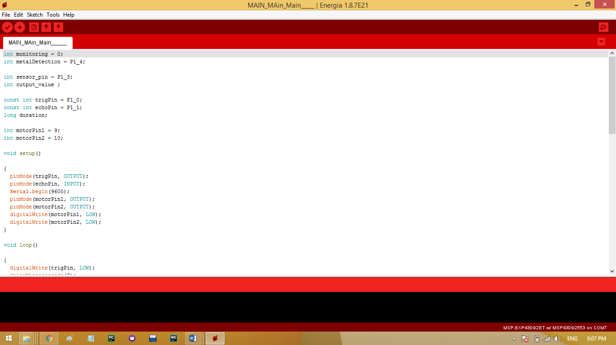

**Figure 6.1 Software Coding**

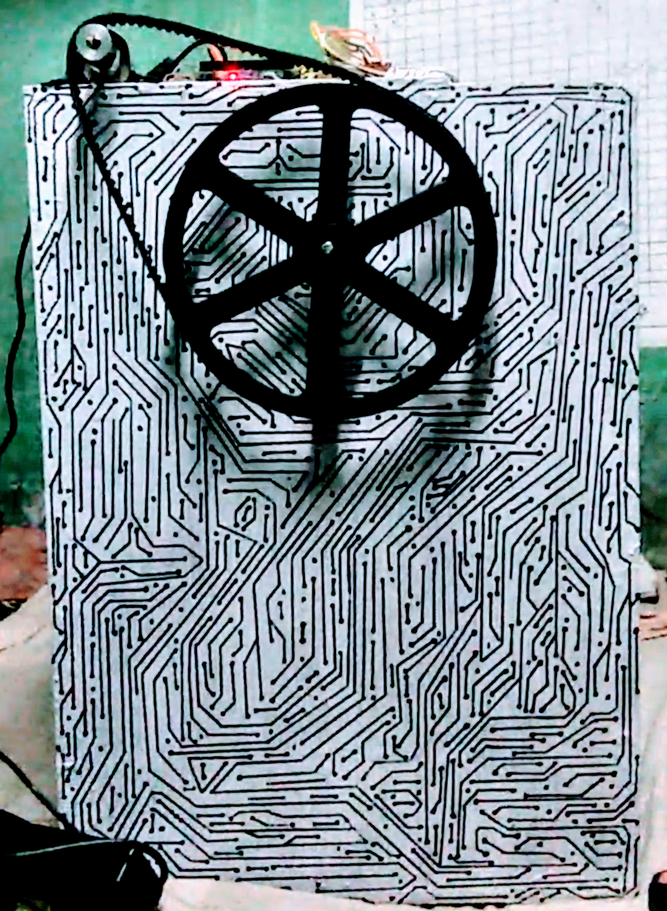

**Figure 6.2 Hardware Result**